Voltaire Segment Dashboard ReadMe
Project Overview:
This project analysis the Voltaire sales dataset using Microsoft excel to identify key business trends and actionable steps that can be taken by Key stakeholders. The dashboard will focus on profitability, sales performance, customer segments and geographical distribution, this visualization allows stakeholders to identify opportunities and business performance.
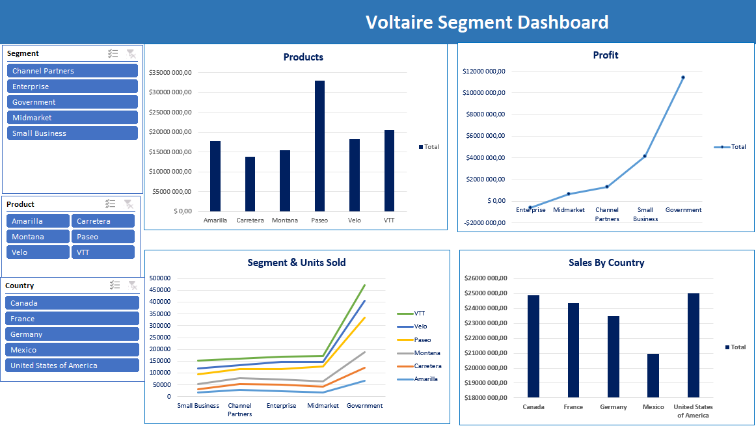
Identify the Problem:
This analysis is to answer the following business questions
- Which three products generated the highest revenue?
- Which product generated the highest revenue?
- Which customer segment performed the worst across all products?
- Which countries generated the highest sale?
Dataset Preparation:
Dataset preparation to ensure quality and data accuracy as followed
- Created a working copy of the original Voltaire dataset to preserve the raw data
- Verified that the dataset contains distinct 9100 records with no duplicates.
- Preparing summary tables for visualization

Data Analysis (Analyse)
Several visualizations to highlight key business insights
Visualizations
- Profit by Segment (Line Chart)
- Units Sold by Segment (Line Chart)
- Sales by Product (Bar Chart)
- Total Sales by country (Bar chart)
Pivot Tables
Sales By Country
- Rows: Country
- Values: Sum of Sales
Profit by Segment
- Rows: Segment
- Values: Sum of Profit
Sales by Product
- Rows: Product
- Values: Sum of Sales
Unit Sold by Segment
- Filter: Country
- Rows: Segment
- Columns: Product
- Values: Sum of Units Sold
Dashboard Features (Share):
The dashboard provides easy to understand overview of business performance
Dashboard Components
- Sales by product
- Profit by segment
- Units Solid by Segment
- Sales by country

Dynamic Filtering (Slicers)
Filter the dashboard by:
- Segment
- Product
- Country
These slicers above allow stakeholders to explore specific business scenarios and compare performance across categories.

Key Findings
- Paseo, VTT and Amarilla generated the highest overall revenue
- The government segment delivered the strongest overall profitability
- The enterprise segment recorded the weakest performance and represents the largest opportunity for improvement.
- North America generated some of the strongest sales performance across the dataset.

Business Impact:
By providing an interactive view of sales performance, profitability, customer segments, products and geographic markets, stakeholders can quickly identify opportunities and areas requiring much needed attention
The analysis delivers value by
- Identifying the highest performing products to support inventory planning, marketing investment and sales prioritization
- Highlight most profitable customer segment enabling for focused resources by management on high value markets
- Revealing underperforming segments that require strategic improvements, pricing adjustment or targeted marketing initiatives.
- Reduced the time required to analyse sales performance by consolidating key metrics into single reporting dashboard.
- Supporting executives and business stakeholders with clear actionable insights for improving the long-term revenue growth and profitability

Expected Business Outcomes
- Improved sales and forecast planning
- Better allocation of marketing and operational resources
- Increased focus on high revenue and high profit products
- Identifying opportunities to improve the performance of underperforming customer segments
- Greater visibility into regional sales trends and customer behaviour
Act:
Recommendations
- Increase marketing efforts and efficient inventory for Paseo, VTT, and Amarilla, as These products contribute the largest share of revenue
- Developing targeted sales strategies with government clients and channel partners so to maintain long term profitability.
- Conduct a thorough review of the enterprise segment to identify the causes of underperformance. Full top down from price adjustments, positing and promotional campaigns and customer engagements
- Continually investing in High performing regions like North America while seeking to improve performance in lower performing markets.
Tools Used
- Microsoft Excel
- Pivot Tables
- Pivot Charts
- Slicers
- SUMIFS
- XLOOKUP
- COUNTIF
- TRIM
- Conditional Formatting
- Data Validation
Skill Demonstrated
- Data Cleaning
- Data Validation Data Analysis
- Business Intelligence
- Dashboard Design
- Data Visualization
- Pivot Tables
- Excel Functions
- Business Recommendations
- Stakeholder Reporting

